Visiting the Holocaust museum

By Nessa Woolf

With additions from Ella Farber Altidor and Noa Goldstein

We gathered on a cold day at the Holocaust museum for an eye-opening experience with our

classmates. Anticipating the adventure ahead but also dreading the thought of knowing in detail what actually happened to our ancestors.

We met a survivor of the Holocaust, taken away from the danger by his parents when he was a baby. During the guided tour, we learned a lot about the Holocaust that most of us didn’t know and saw objects and photographs from that time.

To turn people against the Jewish population so that no one would object to their unfair treatment later on, the Nazis used different forms of media to spread propaganda. They printed children’s books depicting Jews as evil so that children would shun them from a young age, they created board games with similar intentions and caricatures of Jews that were often ugly or disproportionate. Slowly but surely, everyone began to think that they really were always evil, greedy and ugly. No one stood up for them, because everyone thought that they were getting what they deserved.

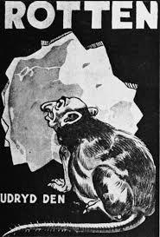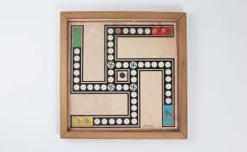

During the war, Jews were separated from the rest of the community by being put into ghettos, little neighbourhoods with walls around them. These ghettos had a strict curfew likely enforced by soldiers and horrible living conditions. Entire families were often forced to live in a single room, or, if they were less fortunate, on the street. Food was very hard to come by and things like paper and ink were either banned or too expensive for most people to afford.

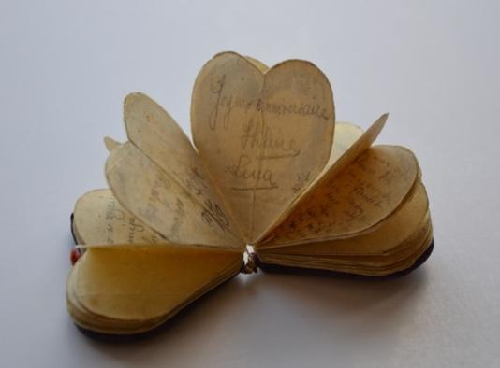

The people in these ghettos didn’t have enough money for things that weren’t strictly necessary, like gifts. However, one girl’s friends gave her a birthday present anyway. They somehow got paper and cut and folded it so that it opened into several different sections like a little heart-shaped booklet. On each of these pages, one of her friends wrote a note. What really touched me about this gesture was that, if they had been caught, they could’ve been killed, but they still did this one little thing for their friend. The girl kept it, keeping it hidden in her armpit during inspections at the camp she was sent to so as not to lose it. Now, decades later, it’s in the museum, helping to tell the sad story of its owner.

Leaving the museum, at the end of the tour, we were talking among us, trying to digest this moment in history that affected us and our families from 1939-1945. This was a hunting passage to experience into the mines of history.

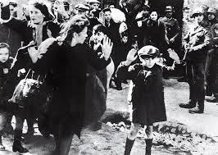

## This is some art from the holocaust

